Schedule Update Email Procedure

Whoever runs the schedule update will need to send out a schedule update email following this procedure.

- When creating and updating a schedule update email follow one of the two options:

  - Paste the master schedule update email template into an email and add the needed information. Every update reply all to the last email update, then copy and edit the information.
  - Create a project specific schedule update email document using the master schedule update email template and save it to your computer with the day’s date. Then copy and paste the information into an email. Every update, make a duplicate document, update the information, and save with that day’s date.

- How to use the master schedule update email template:

  - Fill out the project information:
Project:
Job Number:
Contractual Completion Date:
Projected Substantial Completion Date:

  - Input the number of days either ahead or behind schedule, using green for days ahead and red for days behind:
Days Ahead/Behind Schedule: (Ahead/Behind)

  - Attach the Current Summary Report:

    - Log into SmartPM, find the project on the company dashboard view and select the summary report for the file:
    - Take a screenshot of the summary report using the snipping tool or the shortcut (start+shift+s), then copy and paste it underneath the Days Ahead/Behind Schedule.
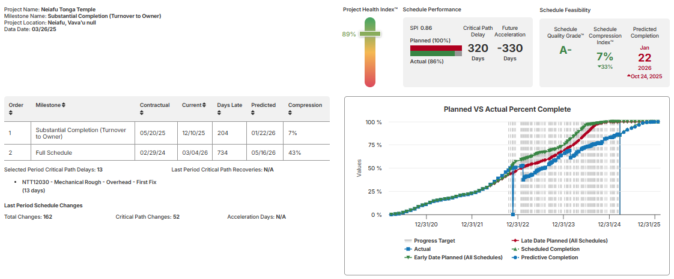
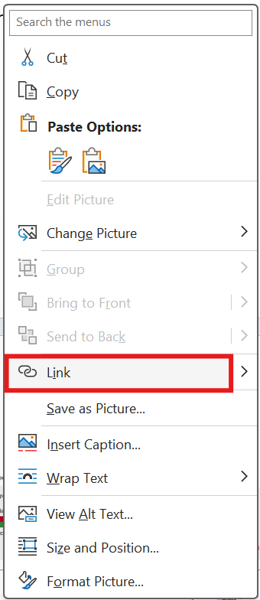
    - Next, open the project in SmartPM and copy the URL from the browser. Right click on your pasted summary report screen shot, select link, and past the URL in the address bar, then hit ok:

  - Input success discussed in the schedule update:
Successes:
Example: The catwalks and ladders were delivered and installed in the maintenance access spaces.

  - Enter the schedule gain or loss since the last update, using green for the gain and red for the loss.
Schedule Gain / Loss Since the Last Update: (Gain/Loss)

  - Input the status of any EOTs and/or Recovery Efforts:
Status Of EOT / Recovery Efforts:
Example: Trade nonperformance has been the primary issue causing our delays. We simply need to perform and complete the work as quickly as possible. The intumescent paint and pending finish changes will allow us to capture some time, but he majority of our delays are internal.

  - Add any significant changes to the schedule logic:
Significant Changes to Schedule Logic:
Example: Multiple changes to logic, sequencing, relationship types, deletions, additions, etc. to capture new scope and offset ongoing delays. I continue to make minor adjustments to improve schedule quality and better comply with DCMA and GAO standards.


  - Insert the SmartPM URL from the change log for the project:
    - Open the project in Smart PM and on the right side of the screen select the changes layout.
    - Copy the URL and post is under the bolded phrase as shown below.
Please refer to the attached Analytics Report, or review schedule changes in SmartPM for specifics. https://live.smartpmtech.com/#/company/39032af1-4b5c-4d22-a81e-9f7c7aabfbc5/project/61595/model/246/milestone/579/changes

  - Red Flags
    - Add any red flags that arose in the update or previous red flags that are still of concern or haven’t been resolved. Bolding or marking in red any that should be focused on.
Red Flags: Examples
1. Extended durations for work that should be complete.
2. Rework for several trades.
3. Trades not following the plan and wandering into low priority areas.

  - Stalled or Slipping Tasks
    - Include any stalled or slipping tasks that were discussed in the update or previous updates that are still of concern or haven’t been resolved. Bolding or marking in red any that should be focused on.
Stalled Or Slipping Tasks
1. Framing in each area is still not complete.
2. Interior HVAC and plumbing rough activities continue to lag farther behind.
3. Too many submittals remain incomplete. We need to pressure the trades to finish this process.

  - Key Items and Issues to Focus On
    - Input the key items and issues to focus on, which were discussed in the update or previous updates that are still of concern or continue to be an item of focus. Bolding or marking in red any that should be focused on.
Key Items & Issues to Focus On
1. Material delays have been a constant concern on this project. We should be conducting in depth material discussions and performing inventory checks with each trade multiple times each week to ensure we are not surprised by another shortage. Early every week we find out about another material item we are missing. We have got to find a better process for securing our materials.
2. We should review production with OPI directly every single day. If work slips in any area, we have got to hold them accountable and help them create and execute recovery plans and beat their dates. Additionally, we need to get detailed packing lists and proof of departure for all material shipments to ensure materials are in transit.


  - Schedule Performance Graphs
    - On the SmartPM Company Dashboard find your project and select
    - Once the screen loads, you’ll need to resize your screen. On your keyboard press and hold ctrl, then while holding it press ( - ) until your screen allows you to screen shot three graphs at once.
    - Take two screenshots. First, take a screenshot of the (activity hit rate, window start accuracy, and window finish accuracy) graphs using the snipping tool or the shortcut (start+shift+s), then copy and paste it underneath the Schedule Performance Graphs explanation. Next, take a screenshot of the (schedule compression index over time, monthly activity start & finish distribution, and SPI over time), then copy and paste is under the other graphs.
    - Next, copy the URL from the browser. Right click on each of your pasted screen shots, select link, and past the URL in the address bar, then hit ok:
Schedule Performance Graphs
The charts below show our actual starts and finishes compared to planned, schedule compression, and monthly activity finish distribution. You can get a better view of these charts and drill down to greater detail regarding specific activities and trade performance by logging on to SmartPM and clicking the View Trends link on the right side of the screen.
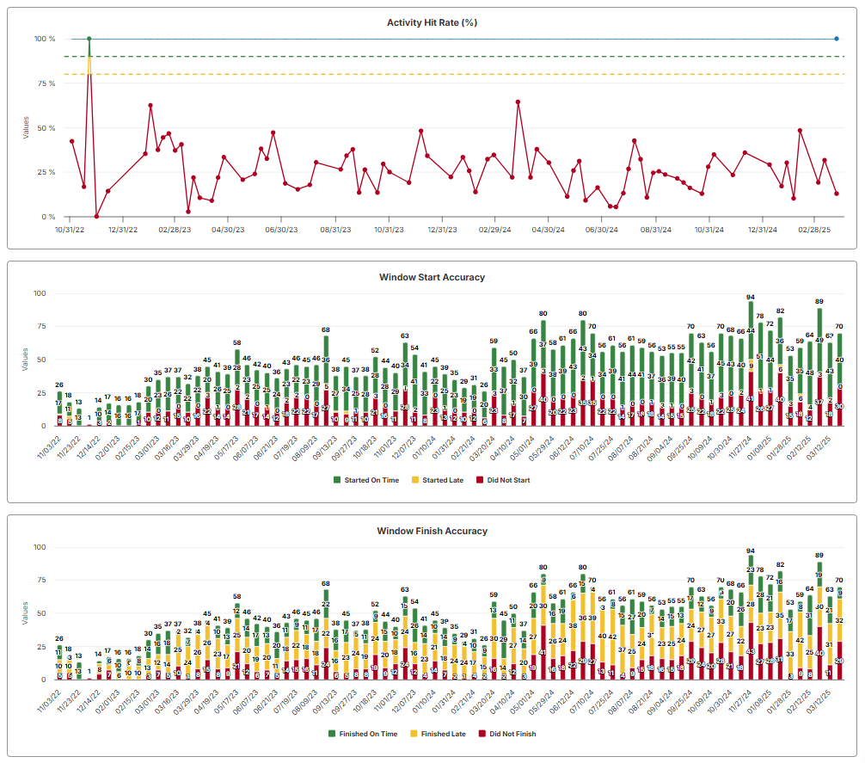
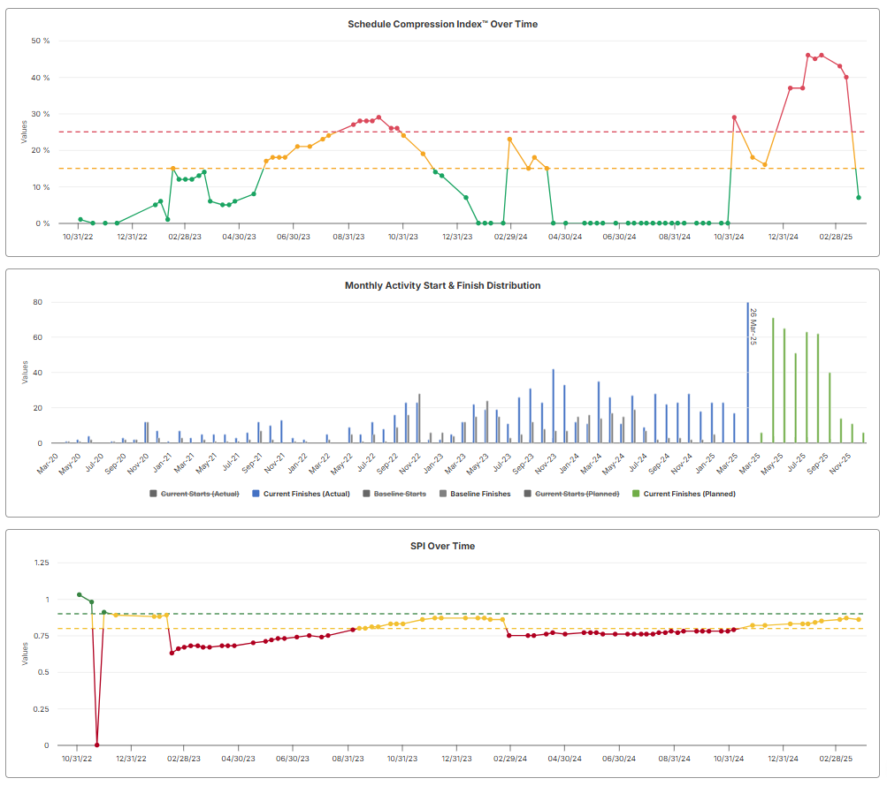

  - Schedule Compliance Report Excel Sheet
    - If applicable attach the Schedule Compliance Report.
I have again included the Schedule Compliance Report in excel for your use. Please note: You will need to verify responsibility for the impacts. This report should be distributed to the Project Team each week and reviewed in detail during the OAC. Please include the form with the meeting minutes and add language to the minutes stating all parties reviewed the Schedule Compliance Report in detail and acknowledge doing so. If they wish to make any adjustments, or contest any information included in the report they may do so by responding to the meeting minutes within 24 hours, or as defined by the contract.

  - Procurement and Progress Spreadsheets
    - If applicable attach the procurement and progress spreadsheets.
I have included the procurement and progress update spreadsheets. Please use these to fill out all actual dates and confirmed durations prior to each update. This will significantly reduce the time we spend updating each week to give us more time to work on recovery planning.

  - What Files to Attach
    - Include the following schedule layout pdfs: Master Schedule, Critical Path, Near Critical, Four Week Lookahead, SmartPM Analytics Report, and any other requested by the project team.
      - You’ll need to run the

  - Who to Send the Report to
    - Send to the project team and CC the project director, and all the scheduling department.

